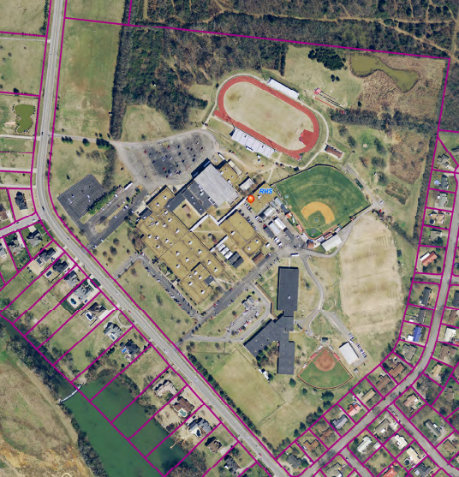

S

Warrior Invitational

Middle School Course Map

1st Mile – green

2nd Mile - yellow

Parking – in football field lot.

Tents -

1