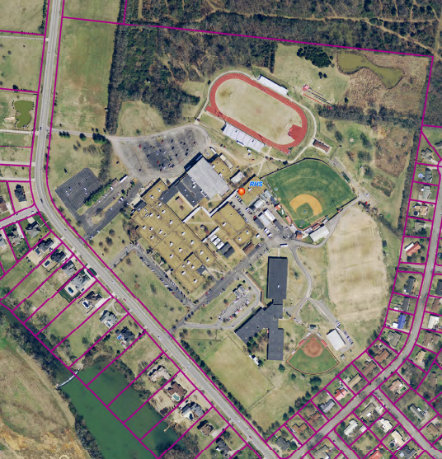

S

Warrior Invitational High School Course Map

1st Mile – green

2nd Mile - blue

3rd Mile - yellow

Parking – in football field lot.

Tents -

3

2

1