MSCCA Member Meet
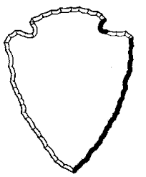 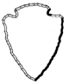
Date- 9-20-16
Location- Arrowhead Ranch
Address- 239 Cortner Mill Road Normandy, Tennessee 37360
Start Times:
MS Girls(1.5 Miles): 4:00 PM
MS Boys(1.5 Miles): 4:30PM
High School Girls Varsity+ JV Combined- 4:45 PM
High School Boy Varsity +JV Combined- 5:30 PM
Registration: Please use the spreadsheet provided on the MSCCA website and send to EHickerson@dcbe.org and phimphivonga@bedfordk12tn.net
Awards: Individual awards will be handed out as runners cross the finish line.
Packets: Each team will receive a packet of information upon arrival. Please come to the tent located at the finish line to pick up your information.
Concessions: There will be no concessions sold at Arrowhead.
If you have any other questions please email Anoulom Phimphivong at phimphivonga@bedordk12tn.net

